Year 9 Mathematics
Test 3 – Surface Area and Volume

 | A  Excellent achievement | B  High Achievement | C  Satisfactory achievement |  | D  Limited Achievement | E  Very low achievement
Description | 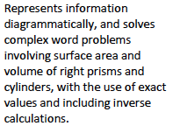 | 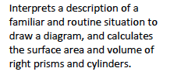 | 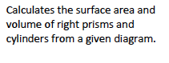 |  | 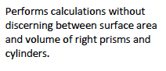 | 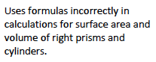
Questions | 12, 13 | 9, 10, 11 | 1, 2, 4, 5, 6, 7, 8 |  | 3
Marks | 3, 4 | 3, 4, 5 | 4, 2, 5, 4, 10, 7, 2 |  | 2
% | 7 out of 55 = 12.7% | 12 out of 55 = 21.8% | 34 out of 55 = 61.8% |  | 2 out of 55 = 3.7% | 0 out of 55 = 0%
ACM | 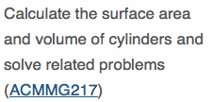 |  |  | 